PSEUDO VISION SYSTEM OF PATH DETECTION , OBSTACLE DETECTION AND AVOIDANCE

A project report
Submitted in partial fulfillment for
The award of the degree of

BACHELOR OF ENGINEERING
IN
COMPUTER SCIENCE AND ENGINEERING

BY

AYUSHI GARG (3BE/4048/06)
ISHA GAUTAM (3BE/4054/06)
MAYANK KUMAR DADHEECH (3BE/4057/06)
SUMIT SINGH (3BE/4074/06)



DEPARTMENT OF COMPUTER SCIENCE AND ENGINEERING
BIRLA INSTITUTE OF TECHNOLOGY
MESRA-835215, RANCHI
2010

DECLARATION CERTIFICATE

This is to certify that the work presented in the project report entitled
“Pseudo Vision System Of Path Detection, Obstacle Detection
And Avoidance” in partial fulfillment of the requirement for the award
of Degree of Bachelors of Engineering in Computer Science and
Engineering of Birla Institute of Technology Mesra, Ranchi is an
authentic work carried out under my supervision and guidance.

To the best of my knowledge , the content of this
project report does not form a basis for the award of any previous
Degree to any one else.

Date : 07/05/2010 Mr. Shripal Vijayvargiya
Dept. of Computer Science and Engineering
Birla Institute Of Technology
Mesra, Ranchi

Head Dean
Dept. of Computer Science and Engineering (Undergraduate Studies)
Birla Institute of Technology Birla Institute of Technology
Mesra, Ranchi-835215 Mesra, Ranchi-835215
CERTIFICATE OF APPROVAL

The foregoing project report entitled “Pseudo Vision System Of Path Detection, Obstacle Detection And Avoidance”, has been found satisfactory in terms of scope, quality and presentation in a manner to warrant its acceptance as prerequisite to the degree for which it has been submitted.

It is understood that by this approval, the undersigned do not necessarily endorse any conclusion drawn or opinion expressed therein, but approve the project for the purpose for which it is submitted.

(Internal Examiner) (External Examiner)

(Chairman)
Head of the Department
ACKNOWLEDGEMENT

We take great privilege in expressing our heartfelt and sincere gratitude to our project supervisor Mr. Shripal Vijayvargiya , Dept. Computer Science and Engineering, Birla Institute of Technology, Mesra, Ranchi for his suggestion and guidance throughout the course of this project and its successful completion.

We would like to convey our sincere thanks to our Head Of Department Dr. Madhavi Sinha, Dept. Computer Science and Engineering for her consistent encouragement and facilities provided for the completion of this course.

We also express our sincere gratitude to all other faculty members and non-teaching staff of the School of Computer Sciences for all the help provided.

Place: Jaipur
Date: 07/05/2010

AYUSHI GARG (3BE/4048/06)
ISHA GAUTAM (3BE/4054/06)
MAYANK KUMAR DADHEECH (3BE/4057/06)
SUMIT SINGH (3BE/4074/06)
TABLE OF CONTENT

1 Introduction 6
1.1 Purpose of The Document 6
1.2 Scope 6
1.3 Definitions, Abbreviations 6
2 The Overall Description 6
2.1 Product Perspective 6
2.2 Product Function 7
2.3 User Characteristics 7
2.4 General Constraints 7
2.5 Assumptions and Dependencies 7
3 System Requirement Specification 7
3.1 Functional Requirements 8
3.2 Hardware Specifications 8
3.3 Software Specification 9
3.4 External Interfaces 9
3.5 Non Functional Requirements 9
4 Data Flow Diagrams 10
4.1 Level 0 10
4.2 Level 1 10
5 Circuit Diagram 11
6 Algorithms 13
6.1 Obstacle Detection 13
6.2 Path Recognition 14
6.3 Decision Making 15
7 Use Case Diagram 15
8 Class Diagram 19
9 IMPLEMENTATION 20
10 RESULT AND CONCLUSION 39
11 References 39

Introduction

Purpose of The Document

This document formally states the requirements for the project and it serves as a requirement reference for the development of the proposed system and forms the basis of the hardware and software design. This document is to define the requirements for the design and development of hardware and software part of an autonomous robot with pseudo-vision system capable of obstacle detection and path recognition. The document serves to set the proper boundary lines needed to be covered for an autonomous system.

Scope

This is a basic prototype of an autonomous robotic system fitted with pseudo-vision capable of obstacle detection and path recognition. This system after proper development will find its application in public and private transport vehicles [1]. With the help of this system, vehicles will be able to reach their destination without any human assistance. This will help reduce accidents caused by human errors. Some other applications include autonomous ship’ collision avoidance system [2], Wheeled Mobile Robots [3], blind and visually impaired system [4], space exploration and related terrestrial applications [5].

Definitions, Abbreviations

- Robot- Any machine or mechanical device that operates automatically with human like skill.
- Autonomous robot- Autonomous robots are robots which can perform desired tasks in unstructured environments without continuous human guidance.
- Pseudo vision obstacle detection- The robot requires means of detecting an obstacle (or another robot) without making physical contact. This allows the robot to decide whether to avoid or to confront and investigate the obstacle depending on its programming.
- Path recognition-- The robot will recognize the path or the track given, and follow it accordingly.
- Image processing-- image processing is any form of signal processing for which the input is an image, such as photographs or frames of video; the output of image processing can be either an image or a set of characteristics or parameters related to the image
- Fuzzy system-- A fuzzy control system is a control system based on fuzzy logic - a mathematical system that analyzes analog input values in terms of logical variables that take on continuous values between 0 and 1, in contrast to classical or digital logic, which operates on discrete values of either 0 and 1 (true and false).

The Overall Description

Product Perspective

The Robot will be an autonomous system. The idea is to embed it with programs written using image processing and soft computing tools which will enable the machine in taking decisions in recognition of path and detection and avoidance of obstacles. The product will be a wheeled robot powered by electric motors with a camera mounted at the top for taking images and pass instructions to the motors using data obtained by processed images.

Product Function

User Requirements

Being an autonomous system once programmed it will complete its tasks by itself and it will not be dependent on any human interference except for the start and stop instructions.

System Requirements

- A wheeled system powered by electric motors with a mounted camera and a processor with image processing and decision making capabilities.
- The system should be capable of identifying the path to be traced using the images.
- The system should be able to detect obstacle placed on the path.
- In the case of obstacle detection the system should be capable to avoid collision.

User Characteristics

The System will be Autonomous so there will be no need of human controller once all the inputs are given to the system.
User needs to give the following input to the system:
- Path to be traced by the system.
- Specify the destination to be reached by the system.
- Give command to the system to start by using a switch mounted on it.

General Constraints

- The path should be easily visible and distinguishable from surrounding environment.
- There should be appropriate lighting on the testing ground.
- There should be a power supply available for the electric motors, camera and the microcontroller.
- The obstacle should be clearly visible and distinguishable and not disguised.
- There should not be any moving objects in the images captured by camera and processed by microcontroller.

Assumptions and Dependencies

This project is based on existing algorithms like Histogram Based Color Difference Fuzzy C-Means (HCDFCM) with Co-ordinate Mapping Relationship (CMR) [6]. Some other algorithms are also being studied like by using neural networks [7].

System Requirement Specification

Functional Requirements

Image Display
Input – Photograph captured by web camera will serve as input to this phase
Process- Image will be transmitted from camera mounted on robot to the processor via wired USB connection.
Output- Images will be displayed on the GUI that have been currently captured.

Object Detection
Input- Images captured from camera will be used as input in this phase.
Process- Appropriate image processing algorithms will be applied to detect the obstacles in the input provided.
Output- Objects will be detected by identifying them using clustering.

Path Recognition
Input- Output of object detection will serve as input to this phase.
Process- Image proceesing and other optimizing techniques will be employed for path identification.
Output- A feasible path will be identified .

Electric Motor Control System
Input- Path identified in the previous stage will serve as input to this stage.
Process- Fuzzy inference system will be made to optimize the speed of the motor, specially across the corners.
Output- Decision regarding the movements of the electric motor will be generated for smoother movement of the machinery.

Hardware Specifications

Camera
- Resolution: 1280 X 960 i.e 1.3 MP

Processor
- RAM: 512 MB (Recommended 1024 MB)
- Hard Disk: 1024 MB

Electric Motors
- RPM : 300
- Voltage Rating: 12 V

Driver Circuit
- IC: L293D (H Bridge)

Software Specification
- Matlab (Version 7.0.0.19920)
- JDK 1.6 or above

External Interfaces

User Interface
Users can only give start and stop interface using a wired remote. No other interface is required.

Hardware Interface
- A Microcontroller to control the operation of the robot.
- A Camera to take images.
- Wheels to drive the robot.
- Input switch to trigger action in the robot by the user.

Communication Interface
Serial/parallel ports interfacing will be used.

Graphical User Interface
Graphical User interface is required to display the images captured by camera.

Non Functional Requirements

Usability
The system developed will serve as a prototype for implementing the objective. The prototype will serve as the basic model for real world applications..

Error Handling
The system will be equipped with all the error handling modules and all exceptions and cases would be considered into account while designing the algorithm.

Hardware Constraints
Hardware constraints for the system are
- Processing speed and memory of processors involved.
- Quality of pictures taken by camera.
- Electric motors.

Performance Constraints
- Robustness of the algorithm is important.
- The system is expected to perform functionally all the requirements mentioned in the document.

Reliability Constraints
The system may get stuck at times because of following reasons erroneous input and noisy images. It may also not work properly in the presence of fast moving obstacles.

Maintainability
The system would be easily maintainable. All the modules of this project would be independent from each other. Though any change in requirements would reflect corresponding changes in the respective modules.

Design Constraints
The system will be designed in such a way that it is easy to use and the algorithm is effective enough to meet the objectives.

Implementation Constraints
The robot and computer are connected through wires, so robot cannot go far beyond the length of the wire.

Data Flow Diagrams

Level 0
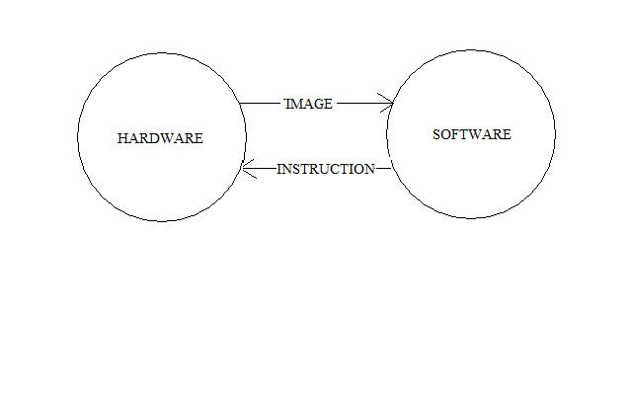
Fig. 1 Level 0 DFD

Level 1

Hardware
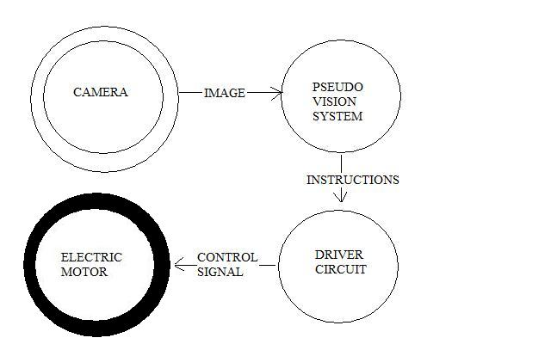

Fig 2. Hardware Components

Electric Motors
Two Electric motors will be used to drive the vehicle wheels. One is for left wheel and the other is for right wheel.
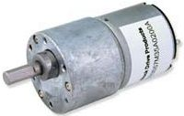
Fig 3: Electric Motor

Driver Circuit
The Driver circuit is used to control the operation of motors. It consists of an H Bridge. L293D is an H Bridge IC. The Motors are connected to it as shown in the circuit diagram. Input is given at Pin 4,5,6,7. Pin 4 and 5 control motor A. Pin 6 and 7 control motor B.

Camera
The Camera is mounted in front of the robot. It is connected to the PC through USB 2.0 port.The Camera is set to take pictures automatically at regular intervals or when triggered through the pc. All the pictures are stored in a folder named ‘Images’ and the images are named by the time stamp at which they are taken. Having the images named by time stamp makes it easier to get the last taken image (and images taken just before that) for processing the result.

Software
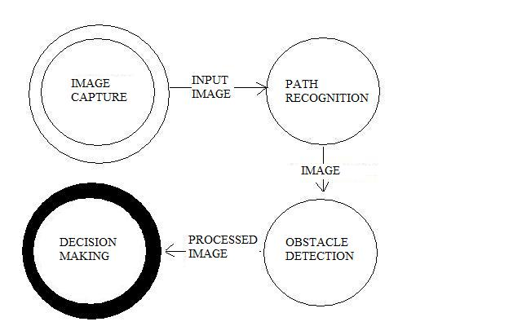
Fig 4: Software Modules

Circuit Diagram
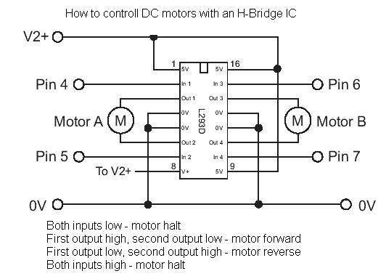
Fig 5: Circuit Diagram of Driver Circuit

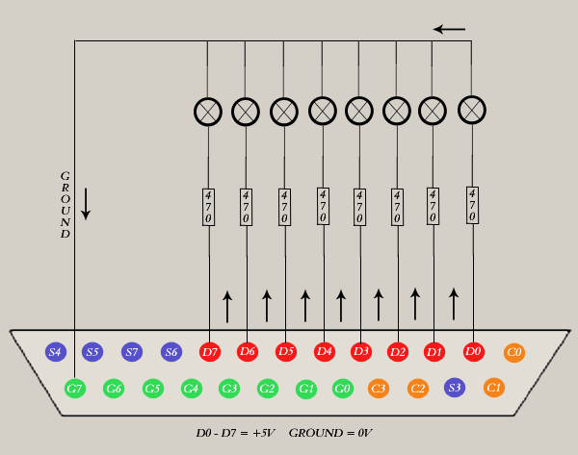

Fig: Parallel Port Circuit

Algorithms

Obstacle Detection
Fig 6: Process Flow of Obstacle Detection Algorithm.
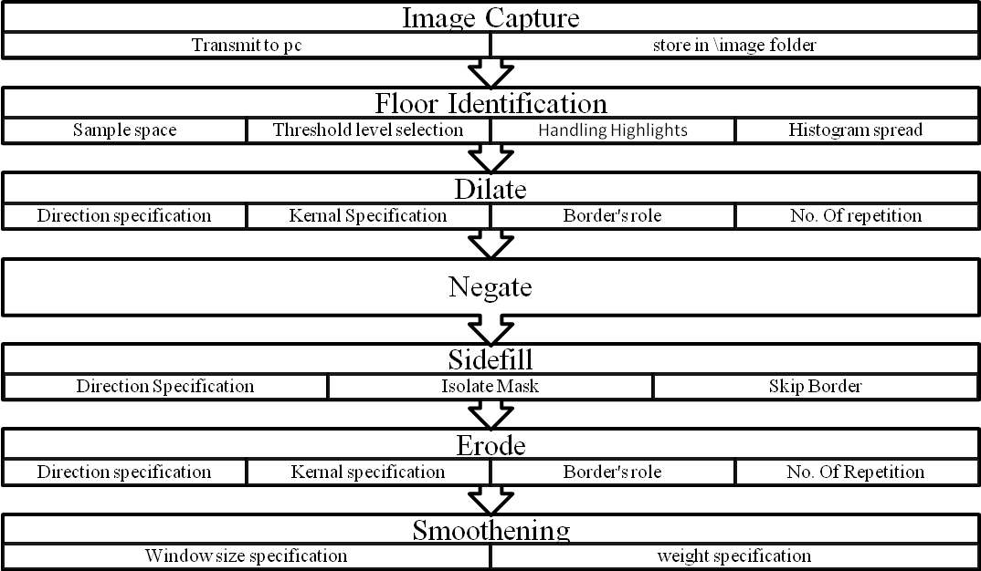fig 7: Detailed Process In Object Detection Algorithm

Image Capture
The image captured by camera will be transmitted to computer and will be stored in image folder. The images in this folder would serve as input to further processing.

Floor Identification
The floor on which the robot is running is identified in this module. The sub steps involved in this are as follows:
- sample space in any user specified or default shape eg triangle or square.
- Select the Threshold level: If the immediate floor space includes obstacles which is setting the threshold high, then it will help remove those obstacle pixels from consideration. This, however, can also remove floor pixels that are slightly “discolored” from the rest.
- Handling highlights (reflections etc).
- Histogram spread.

Dilate
The image is dilated in this module. Sub-steps involved are:
- Specify the direction from which object should be dilated.
- Specification of kernal.
- Border’s role.
- No. Times dilation will take place.

Negate
The image will simply be negated.

Side-fill
The empty space at the bottom of the image is filled as long as an edge is not encountered. It’s sub-steps are as follows:
- Specify the direction from which object should be filled from eg top to bottom.
- Isolate mask.
- Skip border.

Erode
Just eroding or shrinking the current image horizontally by an amount large enough such that the resulting white areas would be large enough for the robot to pass without hitting any obstacle. It is useful for removing noise from an image.
Sub-steps involved are:
  - Specify the direction from which object should be eroded.
  - Specification of kernal.
  - Border’s role.
  - No. Times erosion will take place.

Smoothening
It involves following two steps:
- Specify the Window Size that the outline of the blob will be averaged across.
- Specify the weight that the final outline is biased towards. 0 % is unchanged, 100% means the outline is replaced by the averaged.

Path Recognition
Fig 8: Process Flow Of Path Recognition Algorithm

Decision Making
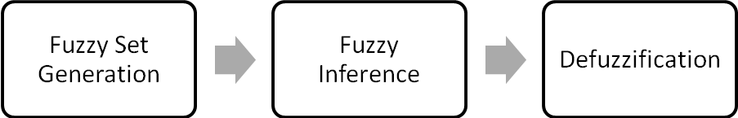
Fig 9. Process Flow Of Decision Making

Use Case Diagram

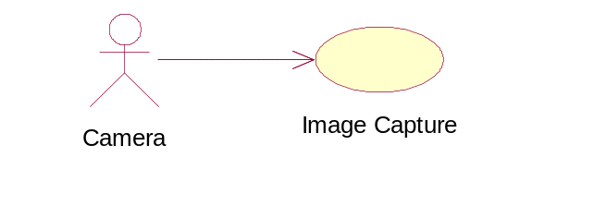
IMAGE CAPTURE
Function: Capture the image
Input: Pixel intensity matrix
Source: Front area of camera
Output: Image
Destination: PC memory
Action: Camera captures the image and then stores in PC memory
Requires: camera ,connecting wires, PC
Pre condition: Good quality camera , ample space and processing speed
Post condition: Image should be saved and processed.

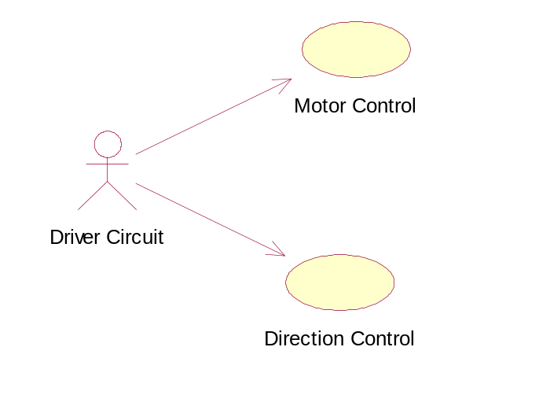
MOTOR CONTROL
Function: Control right and left motors for rotation.
Description: wheels are rotated according to the instructions given by the PC through Motor driver.
Input: Instructions given by the PC.
Source: PC.
Output: voltage instructions to the wheels.
Destination: electric motors.
Requires : Instructions , driver circuit , electric motor.
Pre condition: Input image has been processed and instructions are send to the motors.
Post condition: wheels are rotated and follows the path.
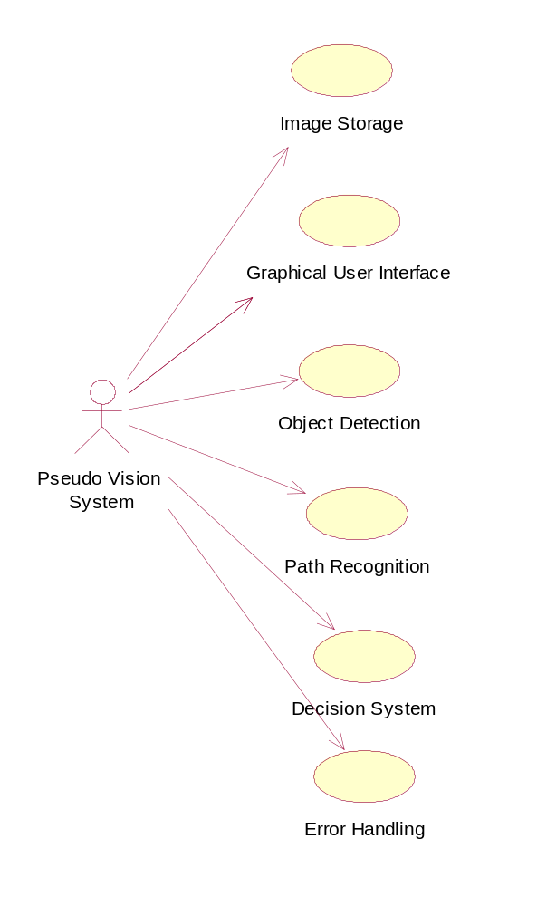
IMAGE STORAGE
Function: Image to be stored at appropriate location.
Description: Path and name based on timestamp is assigned to each image.
Input: Image Captured.
Source : Camera.
Output: Image saved.
Destination: The saved image will be used for further processing.
Requires: Captured image.
Pre condition: Path should be specified.
Post condition: Image will be retrived for image processing algorithms.
GRAPHICAL USER INTERFACE
Function: It will provide basic control and help to user.
Description: User friendly interface would be generated.
Input: Control instructions to user through input devices such as keyboard or mouse.
Source : Input devices such as keyboard or mouse..
Output: Image display and instruction to driver circuit.
Destination: Output devices and driver circuit.
Requires: Captured image.
Pre condition: Nil.
Post condition: Nil.

PATH DETECTION
Function: Path to be traversed.
Description: Path has been detected after the processing of the images.
Input: Image captured.
Source : Camera.
Output: Processed Image for path detection.
Destination: Processed image will go into the Decision making.
Requires: Captured image.
Pre condition: Quality Image should be captured and passed into the PC memory.
Post condition: Processed Image will be send to the PC.

OBJECT DETECTION
Function: Obstacle has been detected and avoided.
Description : It finds the floor and detects all the rest things around as obstacles.
Input : Image captured.
Source : Camera.
Output: processed image for object detection.
Destination : processed image has been send to the decision making.
Requires: Captured image.
Pre condition: Quality Image should be captured and passed into the PC memory.
Post condition: Processed Image will be send to the PC.
DECISION MAKING
Function: Final path , avoiding objects ,has been detected.
Description: Further functioning for the robot has been detected by processing the outputs from path detection and object detection algorithms.
Input: Processed images from path detection and object detection algorithms.
Source: Algorithms from PC.
Output: Instructions to the driver circuit.
Destination: Driver circuit.
Requires: Processed images, PC , Driver circuit.
Pre condition: Processed Images from path detection and object detection algorithm should be send .
Post condition: Instructions will be send to the motor and the robot is moved accordingly.
Error Handling
Function: To handle any run time errors.
Description: Error modules will handle any exception to avoid any abnormal termination.
Input: Nil.
Source: Other software modules.
Output: To print the exception.
Destination: Program control would be tranferred to image capture routine.
Requires: Nil.
Pre condition: Nil.
Post condition: Nil

.

Class Diagram

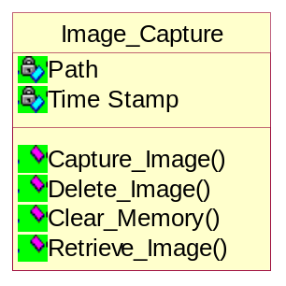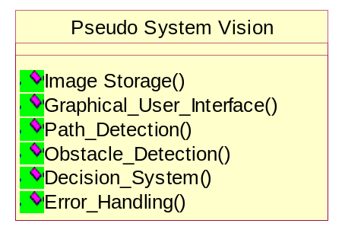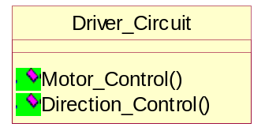

IMPLEMENTATION

SNAPSHOT

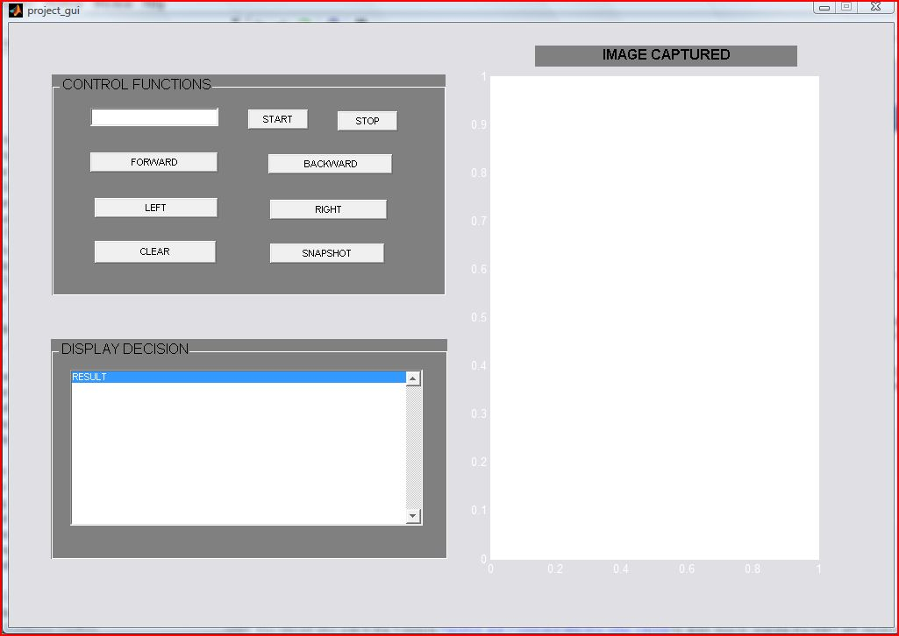

GUI MODULE

Project_gui.m

function varargout = project_gui(varargin)
% PROJECT_GUI M-file for project_gui.fig
% PROJECT_GUI, by itself, creates a new PROJECT_GUI or raises the existing
% singleton*.
%
% H = PROJECT_GUI returns the handle to a new PROJECT_GUI or the handle to
% the existing singleton*.
%
% PROJECT_GUI('CALLBACK',hObject,eventData,handles,...) calls the local
% function named CALLBACK in PROJECT_GUI.M with the given input arguments.
%
% PROJECT_GUI('Property','Value',...) creates a new PROJECT_GUI or raises the
% existing singleton*. Starting from the left, property value pairs are
% applied to the GUI before project_gui_OpeningFunction gets called. An
% unrecognized property name or invalid value makes property application
% stop. All inputs are passed to project_gui_OpeningFcn via varargin.
%
% *See GUI Options on GUIDE's Tools menu. Choose "GUI allows only one
% instance to run (singleton)".
%
% See also: GUIDE, GUIDATA, GUIHANDLES

% Copyright 2002-2003 The MathWorks, Inc.

% Edit the above text to modify the response to help project_gui

% Last Modified by GUIDE v2.5 06-May-2010 20:32:54

% Begin initialization code - DO NOT EDIT
gui_Singleton = 1;
gui_State = struct('gui_Name', mfilename, ...
'gui_Singleton', gui_Singleton, ...
'gui_OpeningFcn', @project_gui_OpeningFcn, ...
'gui_OutputFcn', @project_gui_OutputFcn, ...
'gui_LayoutFcn', [] , ...
'gui_Callback', []);
if nargin && ischar(varargin{1})
gui_State.gui_Callback = str2func(varargin{1});
end

if nargout
[varargout{1:nargout}] = gui_mainfcn(gui_State, varargin{:});
else
gui_mainfcn(gui_State, varargin{:});
end
% End initialization code - DO NOT EDIT

% --- Executes just before project_gui is made visible.
function project_gui_OpeningFcn(hObject, eventdata, handles, varargin)
% This function has no output args, see OutputFcn.
% hObject handle to figure
% eventdata reserved - to be defined in a future version of MATLAB
% handles structure with handles and user data (see GUIDATA)
% varargin command line arguments to project_gui (see VARARGIN)

% Choose default command line output for project_gui
handles.output = hObject;

% Update handles structure
guidata(hObject, handles);

% UIWAIT makes project_gui wait for user response (see UIRESUME)
% uiwait(handles.figure1);

% --- Outputs from this function are returned to the command line.
function varargout = project_gui_OutputFcn(hObject, eventdata, handles)
% varargout cell array for returning output args (see VARARGOUT);
% hObject handle to figure
% eventdata reserved - to be defined in a future version of MATLAB
% handles structure with handles and user data (see GUIDATA)

% Get default command line output from handles structure
varargout{1} = handles.output;

% --- Executes on button press in StartButton.
function StartButton_Callback(hObject, eventdata, handles)
% hObject handle to StartButton (see GCBO)
% eventdata reserved - to be defined in a future version of MATLAB
% handles structure with handles and user data (see GUIDATA)

iterationNo=str2double(get(handles.IterationTextBox,'String'));
disp('iteration no'+iterationNo)
main(iterationNo,handles);

function IterationTextBox_Callback(hObject, eventdata, handles)
% hObject handle to IterationTextBox (see GCBO)
% eventdata reserved - to be defined in a future version of MATLAB
% handles structure with handles and user data (see GUIDATA)

% Hints: get(hObject,'String') returns contents of IterationTextBox as text
% str2double(get(hObject,'String')) returns contents of IterationTextBox as a double

% iterationNo=str2double(get(hObject,'String'));

% --- Executes during object creation, after setting all properties.
function IterationTextBox_CreateFcn(hObject, eventdata, handles)
% hObject handle to IterationTextBox (see GCBO)
% eventdata reserved - to be defined in a future version of MATLAB
% handles empty - handles not created until after all CreateFcns called

% Hint: edit controls usually have a white background on Windows.
% See ISPC and COMPUTER.
if ispc
set(hObject,'BackgroundColor','white');
else
set(hObject,'BackgroundColor',get(0,'defaultUicontrolBackgroundColor'));
end

% --- Executes on button press in StopButton.
function StopButton_Callback(hObject, eventdata, handles)
% hObject handle to StopButton (see GCBO)
% eventdata reserved - to be defined in a future version of MATLAB
% handles structure with handles and user data (see GUIDATA)

port=ConfigureParallelPort(handles);
StopMotor(port,handles);

% --- Executes on button press in LeftButton.
function LeftButton_Callback(hObject, eventdata, handles)
% hObject handle to LeftButton (see GCBO)
% eventdata reserved - to be defined in a future version of MATLAB
% handles structure with handles and user data (see GUIDATA)

port=ConfigureParallelPort(handles);
LeftTurn(port,handles);

% --- Executes on button press in RightButton.
function RightButton_Callback(hObject, eventdata, handles)
% hObject handle to RightButton (see GCBO)
% eventdata reserved - to be defined in a future version of MATLAB
% handles structure with handles and user data (see GUIDATA)

port=ConfigureParallelPort(handles);
RightTurn(port,handles);

% --- Executes on button press in ForwardButton.
function ForwardButton_Callback(hObject, eventdata, handles)
% hObject handle to ForwardButton (see GCBO)
% eventdata reserved - to be defined in a future version of MATLAB
% handles structure with handles and user data (see GUIDATA)

port=ConfigureParallelPort(handles);
MoveForward(port,handles);

% --- Executes on button press in BackwardButton.
function BackwardButton_Callback(hObject, eventdata, handles)
% hObject handle to BackwardButton (see GCBO)
% eventdata reserved - to be defined in a future version of MATLAB
% handles structure with handles and user data (see GUIDATA)

% --- Executes on button press in VideoCheckBox.
function VideoCheckBox_Callback(hObject, eventdata, handles)
% hObject handle to VideoCheckBox (see GCBO)
% eventdata reserved - to be defined in a future version of MATLAB
% handles structure with handles and user data (see GUIDATA)

% Hint: get(hObject,'Value') returns toggle state of VideoCheckBox

% --- Executes on button press in ImageTextBox.
function ImageTextBox_Callback(hObject, eventdata, handles)
% hObject handle to ImageTextBox (see GCBO)
% eventdata reserved - to be defined in a future version of MATLAB
% handles structure with handles and user data (see GUIDATA)

% Hint: get(hObject,'Value') returns toggle state of ImageTextBox

% --- Executes on button press in checkbox4.
function checkbox4_Callback(hObject, eventdata, handles)
% hObject handle to checkbox4 (see GCBO)
% eventdata reserved - to be defined in a future version of MATLAB
% handles structure with handles and user data (see GUIDATA)

% Hint: get(hObject,'Value') returns toggle state of checkbox4

% --- Executes on button press in TransformCheckBox.
function TransformCheckBox_Callback(hObject, eventdata, handles)
% hObject handle to TransformCheckBox (see GCBO)
% eventdata reserved - to be defined in a future version of MATLAB
% handles structure with handles and user data (see GUIDATA)

% Hint: get(hObject,'Value') returns toggle state of TransformCheckBox

function edit2_Callback(hObject, eventdata, handles)
% hObject handle to edit2 (see GCBO)
% eventdata reserved - to be defined in a future version of MATLAB
% handles structure with handles and user data (see GUIDATA)

% Hints: get(hObject,'String') returns contents of edit2 as text
% str2double(get(hObject,'String')) returns contents of edit2 as a double

% --- Executes during object creation, after setting all properties.
function edit2_CreateFcn(hObject, eventdata, handles)
% hObject handle to edit2 (see GCBO)
% eventdata reserved - to be defined in a future version of MATLAB
% handles empty - handles not created until after all CreateFcns called

% Hint: edit controls usually have a white background on Windows.
% See ISPC and COMPUTER.
if ispc
set(hObject,'BackgroundColor','white');
else
set(hObject,'BackgroundColor',get(0,'defaultUicontrolBackgroundColor'));
end

% --- Executes during object creation, after setting all properties.
function StartButton_CreateFcn(hObject, eventdata, handles)
% hObject handle to StartButton (see GCBO)
% eventdata reserved - to be defined in a future version of MATLAB
% handles empty - handles not created until after all CreateFcns called

% --- Executes during object creation, after setting all properties.
function uipanel1_CreateFcn(hObject, eventdata, handles)
% hObject handle to uipanel1 (see GCBO)
% eventdata reserved - to be defined in a future version of MATLAB
% handles empty - handles not created until after all CreateFcns called

% --- Executes on button press in SnapshotButton.
function SnapshotButton_Callback(hObject, eventdata, handles)
% hObject handle to SnapshotButton (see GCBO)
% eventdata reserved - to be defined in a future version of MATLAB
% handles structure with handles and user data (see GUIDATA)

vid=ConfigureVid(handles);
start(vid);% vid='hello';
TakeSnapshot(vid,handles);
stop(vid);

function ResultTextBox_Callback(hObject, eventdata, handles)
% hObject handle to ResultTextBox (see GCBO)
% eventdata reserved - to be defined in a future version of MATLAB
% handles structure with handles and user data (see GUIDATA)

% Hints: get(hObject,'String') returns contents of ResultTextBox as text
% str2double(get(hObject,'String')) returns contents of ResultTextBox as a double

% --- Executes during object creation, after setting all properties.
function ResultTextBox_CreateFcn(hObject, eventdata, handles)
% hObject handle to ResultTextBox (see GCBO)
% eventdata reserved - to be defined in a future version of MATLAB
% handles empty - handles not created until after all CreateFcns called

% Hint: edit controls usually have a white background on Windows.
% See ISPC and COMPUTER.
if ispc
set(hObject,'BackgroundColor','white');
else
set(hObject,'BackgroundColor',get(0,'defaultUicontrolBackgroundColor'));
end

% --- Executes on selection change in ResultList.
function ResultList_Callback(hObject, eventdata, handles)
% hObject handle to ResultList (see GCBO)
% eventdata reserved - to be defined in a future version of MATLAB
% handles structure with handles and user data (see GUIDATA)

% Hints: contents = get(hObject,'String') returns ResultList contents as cell array
% contents{get(hObject,'Value')} returns selected item from ResultList

% --- Executes during object creation, after setting all properties.
function ResultList_CreateFcn(hObject, eventdata, handles)
% hObject handle to ResultList (see GCBO)
% eventdata reserved - to be defined in a future version of MATLAB
% handles empty - handles not created until after all CreateFcns called

% Hint: listbox controls usually have a white background on Windows.
% See ISPC and COMPUTER.
if ispc
set(hObject,'BackgroundColor','white');
else
set(hObject,'BackgroundColor',get(0,'defaultUicontrolBackgroundColor'));
end

% --- Executes on button press in ClearButton.
function ClearButton_Callback(hObject, eventdata, handles)
% hObject handle to ClearButton (see GCBO)
% eventdata reserved - to be defined in a future version of MATLAB
% handles structure with handles and user data (see GUIDATA)

set(handles.ResultList,'String','RESULT');
MAIN MODULE

main.m

function main(N,handles)

SetText('################################',handles);
disp('Asmi Started');
SetText('Asmi Started',handles);

port=ConfigureParallelPort(handles);

vid=ConfigureVid(handles);
start(vid);

while(vid.FramesAcquired<=N) % Stop after 100 frames
SetText('************',handles);
TakeSnapshot(vid,handles);
x=ReadImage(handles);
x=ConvertToGray(x,handles);
x=Normalize(x,handles);
x=DetectEdge(x,handles);
[a,b]=Defuzzify(x,handles);
SendDecision(a,b,port,handles);

end

stop(vid);
disp('Asmi Stopped');
SetText('Asmi Stopped',handles);
SetText('################################',handles);

PARALLEL PORT MODULE

function [data1,str]=ConfigureParallelPort(handles)

DIO = digitalio('parallel','LPT1');
data1 = addline(DIO,0:7,0,'out'); %Pin 2-9
data2 = addline(DIO,0,2,'out'); %Pin 1
data3 = addline(DIO,1,2,'out') ;%Pin 14

SetText('Parallel Port Configured',handles);

IMAGE READING MODULE

ReadImage.m

function x=ReadImage(handles)

x=imread('Asmi.jpg'); % Reading captured image from matlab works

SetText('Image Read',handles);

SNAPSHOT MODULE

TakeSnapshot.m

function TakeSnapshot(vid,handles)

% % vid=ConfigureVid();
% vid=videoinput('winvideo'); % Setting up video device
% set(vid,'TriggerRepeat',inf); % Configuring adapter
% vid.FrameGrabInterval=1; % Setting frame capture interval
% vid_src=getselectedsource(vid); % Setting up video source
% set(vid_src,'Tag','Autobot'); % Setting attribute to the source
% start(vid);

% SetText('Camera Configured',handles);

data = getsnapshot(vid); % Getting snapshot
imshow(data); % Displaying snapshot in window
imwrite(data,'Asmi.jpg');
SetText('Snapshot taken',handles);

% stop(vid);

Configure Camera

ConfigureVid.m

function vid=ConfigureVid(handles)

vid=videoinput('winvideo'); % Setting up video device
set(vid,'TriggerRepeat',inf); % Configuring adapter
vid.FrameGrabInterval=10; % Setting frame capture interval
vid_src=getselectedsource(vid); % Setting up video source
set(vid_src,'Tag','Autobot'); % Setting attribute to the source

SetText('Camera Configured',handles);

Gray Conversion

ConvertToGray.m

function y=ConvertToGray(x,handles)

y = .2989*x(:,:,1)... % Converting image into grayscale
+.5870*x(:,:,2)...
+.1140*x(:,:,3);

min(y(:))
ans =0;

max(y(:))
ans = 255;

colormap(gray(256));
SetText('Converted to gray',handles);
disp('Converted to gray');

Defuzzification

Defuzzify.m

function [n2,n3]=Defuzzify(k,handles)

n0=0;
n1=0;

for i=1:287
for j=1:351
if j<175
n0=n0+k(i,j);
elseif j>175
n1=n1+k(i,j);
end
end
end

disp(n0); % Test of no of pixels on right and left side of screen
disp(n1);

n2=0;
n3=0;
n4=0;

for i=1:287
for j=1:351
if k(i,j)==1
n2=n2+i; % X co-ordinate for balanced pixel
n3=n3+j; % Y co-ordinate for balanced pixel
n4=n4+1; % Total pixels encounterd with intensity 1
end
end
end

if n4 ~= 0
n2=n2/n4; % Pixel co-ordinates to head to
n3=n3/n4;
end

disp('n2=');
disp(n2);
disp('n3=');
disp(n3);
disp('Defuzzified');
SetText('Defuzzified',handles);

Edge Detection

DetectEdge.m

function k=DetectEdge(y,handles)

k=edge(y); % Sobel edge detection by default
disp('Edge Detected');
SetText('Edge Detected',handles);

Edge.m

for i=1:400
for j=1:600
if (z(i,j)<255)
z(i,j)=z(i,j)+1;
end
end
end

for i=2:397
for j=2:597

t=0;
for k=i-1:i+1
for l=j-1:j+1
t=t+z(k,l);
end
end

% u(i,j)=255-(((z(i-2,j-2)*-1)+(z(i-2,j-1)*-1)+(z(i-2,j)*-1)+(z(i-2,j+1)*-1)+(z(i-2,j+2)*-1)+(z(i+2,j-2)*-1)+(z(1+2,j-1)*-1)+(z(i+2,j)*-1)+(z(i+2,j+1)*-1)+(z(i+2,j+2)*-1)+(z(i-1,j-2)*-1)+(z(i-1,j+2)*-1)+(z(i,j-2)*-1)+(z(i,j+2)*-1)+(z(i+1,j-2)*-1)+(z(i+1,j+2)*-1)+(16*z(i,j)))/1);
u(i,j)=255-(((z(i-1,j-1)*-1)+(z(i-1,j)*-1)+(z(i-1,j+1)*-1)+(z(i,j-1)*-1)+(z(i,j+1)*-1)+(z(i+1,j-1)*-1)+(z(i+1,j)*-1)+(z(i+1,j+1)*-1)+z(i,j)*8));
%u(i,j)=cast(u(i,j)/t,'uint8');

end
end

imview(u);

Normalization

Normalize.m

function z=Normalize(y,handles)

z=imadjust(y); % Normalization
disp('Image Normalized');
SetText('Image Normalized',handles);

Decision Making

SendDecision.m

function SendDecision(n3,n2,data1,handles)

if n3<90
% Go right
LeftTurn(data1,handles);
pause(0.07);
StopMotor(data1,handles);

elseif n3 > 180
% Go left

RightTurn(data1,handles);
pause(0.1);
StopMotor(data1,handles);
else
% Go forward
MoveForward(data1,handles);
pause(0.1);
StopMotor(data1,handles);

End

Stop Motor

StopMotor.m

function StopMotor(data1,handles)

putvalue(data1,[0 0 0 0 0 0 0 0]);
disp('Stop');
SetText('Motor Stopped',handles);

Set Text

SetText.m

function SetText(str,handles)

ResultsStr = get(handles.ResultList,'String');
ResultsStr=strvcat(ResultsStr,str);
set(handles.ResultList,'String',ResultsStr);

Robot Movement

MoveForward.m

function MoveForward(data1,handles)

putvalue(data1,[0 1 0 1 0 0 0 0]);
disp('Forward');
SetText('Forward',handles);

RightTurn.m

function RightTurn(data1,handles)

putvalue(data1,[0 1 0 0 0 0 0 0]);
disp('RightTurn');
SetText('Right Turn',handles);

LeftTurn.m

function LeftTurn(data1,handles)

putvalue(data1,[0 0 0 1 0 0 0 0]);
disp('LeftTurn');
SetText('Left Turn',handles);

Obstacle Detection

clc;
clear all;
close all;

vid=videoinput('winvideo'); % Setting up video device
set(vid,'TriggerRepeat',inf); % Configuring adapter
vid.FrameGrabInterval=10; % Setting frame capture interval
vid_src=getselectedsource(vid); % Setting up video source
set(vid_src,'Tag','Autobot'); % Setting attribute to the source
figure; % Opening image window
start(vid); % Starting image capture device

while(vid.FramesAcquired<=10) % Stop after given frames
% clc;
% close all;
data = getsnapshot(vid); % Getting snapshot
imshow(data); % Displaying snapshot in window
imwrite(data,'myobstacle.jpg');

x=imread('myobstacle.jpg');
imview(x);
y=x; % iy=143;
% averaging
[ix,iy,iz]=size(x)

i=1;
loop=1;

i=1;
while(i<=3)
j=3;
while(j<ix-3)
k=3;
while(k<iy-3)

y(j,k,i)=y(j-1,k-1,i)/34+y(j-1,k,i)/34+y(j-1,k+1,i)/34+y(j,k-1,i)/34+y(j+1,k-1,i)/34+y(j,k+1,i)/34+y(j+1,k+1,i)/34+y(j+1,k,i)/34+y(j,k,i)/34;
y(j,k,i)=y(j,k,i)*2;
y(j,k,i)=y(j,k,i)+y(j-2,k-2,i)/34+y(j-2,k-1,i)/34+y(j-2,k,i)/34+y(j-2,k+1,i)/34+y(j-2,k+2,i)/34+y(j-1,k-2,i)/34+y(j-1,k+2,i)/34+y(j,k-2,i)/34+y(j,k+2,i)/34+y(j+1,k-2,i)/34+y(j+1,k+2,i)/34+y(j+2,k-2,i)/34+y(j+2,k-1,i)/34+y(j+2,k,i)/34+y(j+2,k+1,i)/34+y(j+2,k+2,i)/34;
k=k+1;
end;
j=j+1;
end;
i=i+1;
end;
loop=loop+1;

imview(y);

%base point (160,225)- 142 146 125
base_x=106;
base_y=68;
y(base_x,base_y,1)
z=zeros(ix,iy);
j=1;
while(j<ix)
k=1;
while(k<iy)
i=1;
s=0;
while(i<=3)
if(y(base_x,base_y,i)<y(j,k,i))
r=abs(y(j,k,i)-y(base_x,base_y,i));
else
r=y(base_x,base_y,i)-y(j,k,i);
end;
if(j==9 & k==310)
r=abs(r)
end;
s=double(s+r);
i=i+1;
end;

if((255*((s-765)*(s-765)/(765*765)))<190)%value of 170 should be evaluated according to photo automatically
z(j,k)=0;
else
z(j,k)=255;
end;
k=k+1;
end;
j=j+1;
end;

imview(z);
%imwrite(z,'simple.jpg');

for i=1:287 % Check every line from bottom and mke it dark as a black pixel is detected
j=357;
f=1;
while(f==1)
if z(i,j)==0
while(j~=0)
z(i,j)=0;
j=j-1;
end
f=0;
end
end
end

n0=0;
n1=0;
n2=0;

for i=1:287
for j=1:351
if k(i,j)==1
n0=n0+i; % X co-ordinate for balanced pixel
n1=n1+j; % Y co-ordinate for balanced pixel
n2=n2+1; % Total pixels encounterd with intensity 1
end
end
end
if n2 ~= 0
n0=n0/n2; % Pixel co-ordinates to head to
n1=n1/n2;
end

disp('n0=');
disp(n0);
disp('n1=');
disp(n1);

% Pass instruction to the driver circuit
if n1<90
% Go left
putvalue(data1,[0 1 0 0 0 0 0 0]);
disp('Left');

elseif n1 > 180
% Go right
putvalue(data1,[0 0 0 1 0 0 0 0]);
disp('Right');

else
putvalue(data1,[0 1 0 1 0 0 0 0]);
disp('Center');

end
end
stop(vid);
close;

RESULT AND CONCLUSION

The system is capable of detecting and traversing a specified path and avoiding obstacles in the way autonomously. Its performace can be improved further by applying advanced hardware interface.The application developed can be further extended to add more and advanced features depending on the requirements of the system it is developed for. It can even be modified to suit the different types of systems as there prerequisites ; Further advancements will lead to better and more useful application being developed for future uses and more compatibility to the emerging technologies. It could be further applied to real time applications where the execution of modules is constrained by timing deadlines.

11 References
- Thavida Maneewarn, Prasopchai sila-on, Rubkwan Jitpakdee, Amornsri Khitwongwattana and Xye, “Road Following and Obstacle avoidance system for an Unmanned Ground Vehicle.” KMUTT, April 2009.
- Cheng-Neng Hwang, Joe-Ming Yang and Chung-Yen Chiang, “The design of fuzzy collision-avoidance expert system implemented by h∞ autopilot.” Journal of Marine Science and Technology, Vol. 9, No. 1, pp. 25-37 , 2001.
- Aye Aye Nwe, Wai Phyo Aung and Yin Mon Myint , “Software Implementation of Obstacle Detection and Avoidance System for Wheeled Mobile Robot.” World Academy of Science, Engineering and Technology 42, 2008.
- Dr. Shraga Shoval, Mr. Iwan Ulrich and Dr. Johann Borenstein. ”Computerized Obstacle Avoidance Systems for the Blind and Visually Impaired.” Invited chapter in "Intelligent Systems and Technologies in Rehabilitation Engineering,” pp 414-448, 12/26/2000.
- http://www-robotics.jpl.nasa.gov/
- Tsung-Ying Sun, Shang-Jeng Tsai, Jiun-Yuan Tseng, and Yen-Chang Tseng “The Study on Intelligent Vehicle Collision-Avoidance System with Vision Perception and Fuzzy Decision Making.” Proceedings of Intelligent Transportation Systems, pp no. 486-491, September, 2005.
- Takeo Kato, Yoshiki Ninomiya, and Ichiro Masaki, “Proceeding Vehicle Recognition Based on Learning From Sample Images,” IEEE Trans. On Intelligent Transportation System, vol. 3, no. 4, 2002.

